**Wait-Less Employee Login Scenario**

**Group 22 - Brian Goldenberg, Omar Salas, Harsh Gupta, Emmanuel Utomi**

The **Wait-Less** application will eventually allow all staff members in the restaurant to utilize the app to their specific role, pinging other employees based on urgency, assisting tables based on a first come first serve bases etc. The first scenario describes what happens when a manager or waiter logs into the application.

**Scenario “Employee Login”**

The application begins with a login screen. The employee will type in their employee ID and passcode. The program then attempts to authenticate their login information. After successful authentication the application enters the welcome screen where it will successfully identify whether an employee is a waiter or manager. If there is any issue authenticating the employee the application will display “Invalid employee ID or passcode”.

If an employee has forgotten their login information, a manager can login with their own ID and passcode so they can reset the other employee’s ID and (if needed) their passcode. If all employees (including the managers) have forgotten their login information, then customer support must be contacted to get their login information back.

If a waiter has logged in, it will show all the waiter main menu. This main menu contains an alert section that shows them their notifications. These include anything from tables that need attending, food that is ready to be served, tables that are requesting waiter assistance, etc. Another section is a layout of their tables (top view of the restaurant), this section can be clicked to get enlarged for a better view. This section contains information on the tables that the waiter is assigned to. The final section is a UI menu item list (not restaurant menu list) which contains buttons for:

* Statistics, like average waiting time, tables served, time elapsed for their shift, etc.
* Start shift (starting for the day and coming back from lunch break)
* End shift (ending for the day and going on a lunch break)
* Logging out

If a manager logs into the application it will show an overview screen will appear. This screen will show the same menu layout as a waiter. The alert section will notify the manager when an alert that is sent to a waiter stays unattended beyond a certain threshold. This way the manager can confront the waiter to check their alerts and be on top of everything. The top view of the restaurant section contains information on all the tables. The final section is the button list for different functions:

* Statistics, this is the same as the waiter statistics but for every waiter
* Start shift
* End shift
* Restaurant functions, like closing the restaurant, counting registers, employee shifts, etc.
* Logging out

Login Diagram:

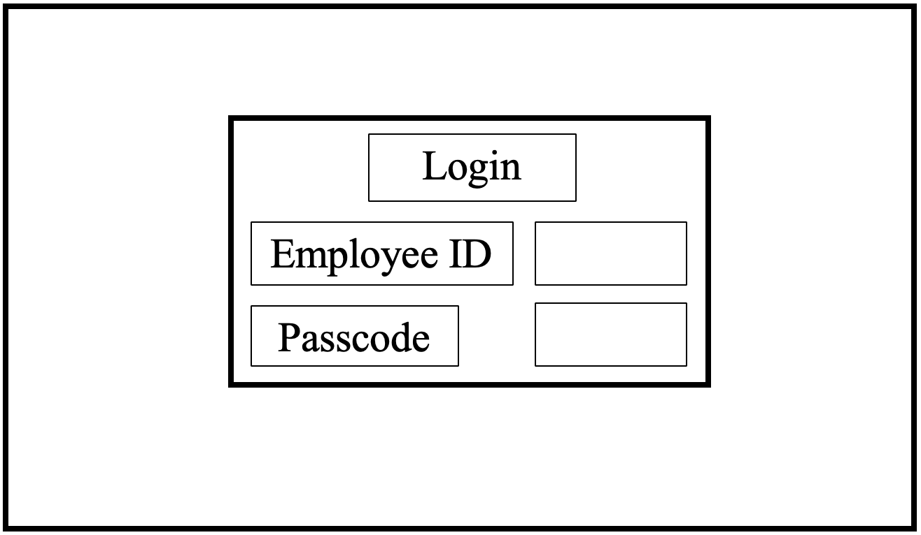

Main Menu Diagram:

